Jihan Lathifah Imtinan
Universitas Bhayangkara Jakarta Raya
07 April 2026
Tugas 3 React JS
- Link github
- Tampilan
Menampilkan data 9 buku di halaman home dan halaman Book, seperti arahan tugas
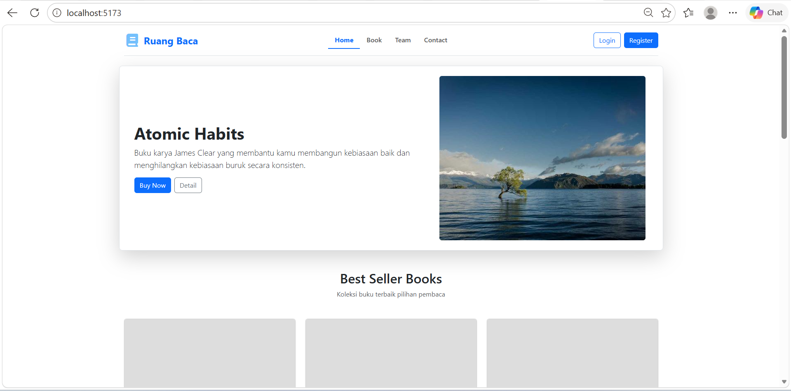
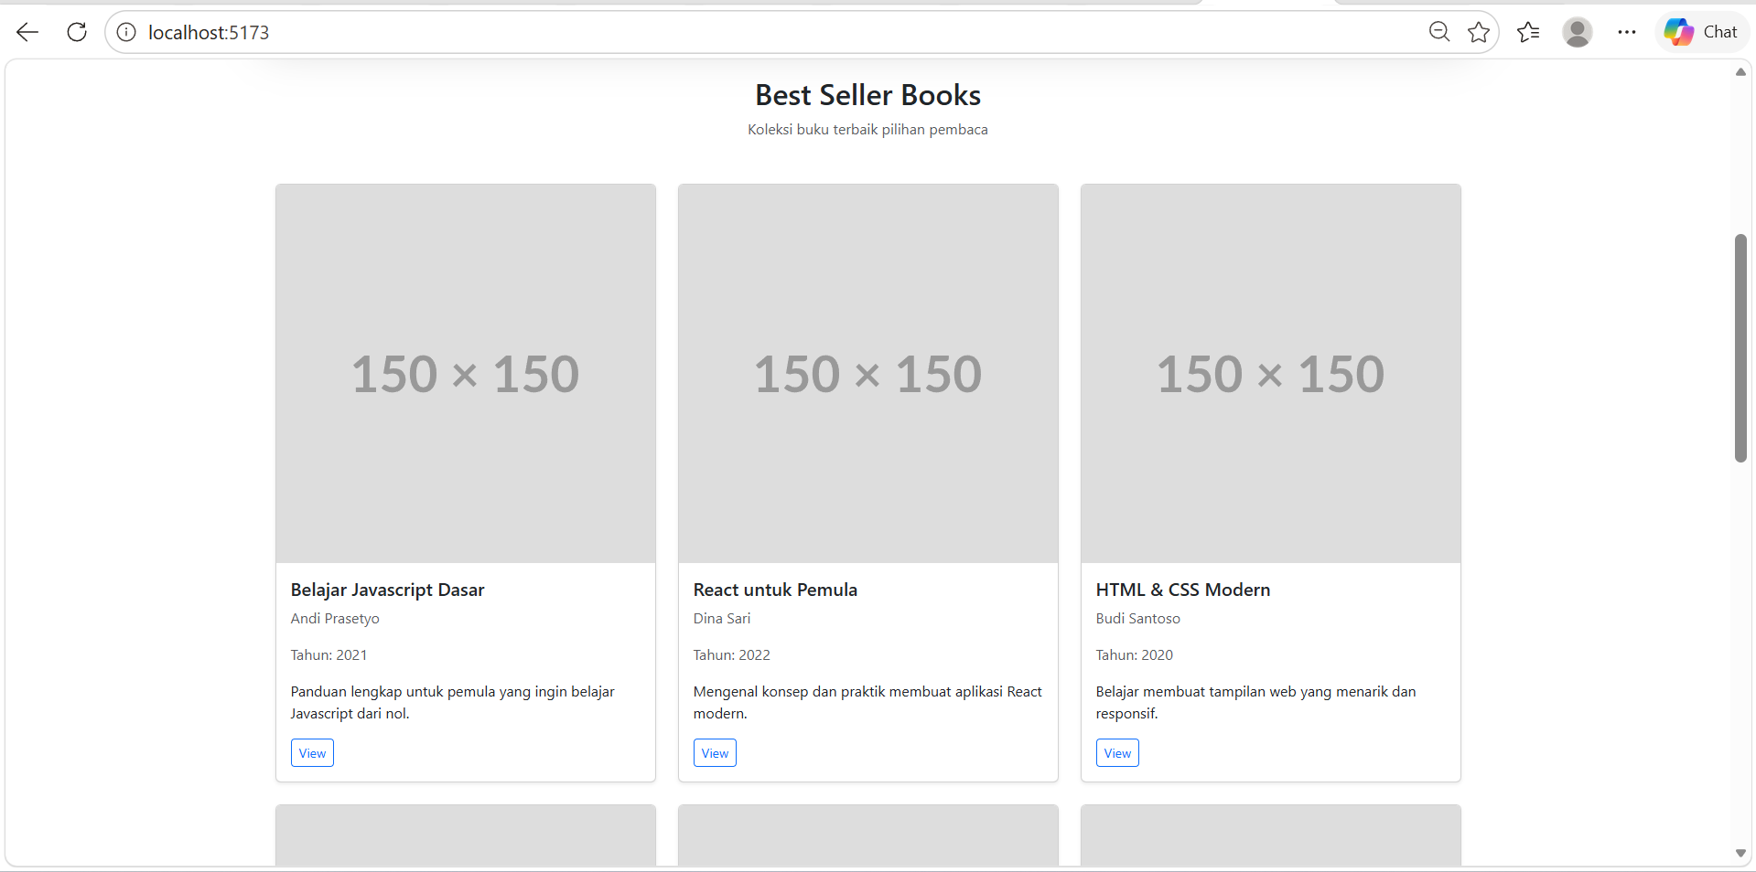

Ini di bagian halaman book
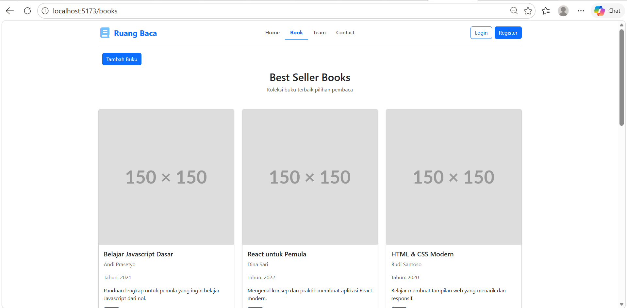

Jika klik Tambah buku akan muncul notifikasi "Buku berhasil ditambahkan!"

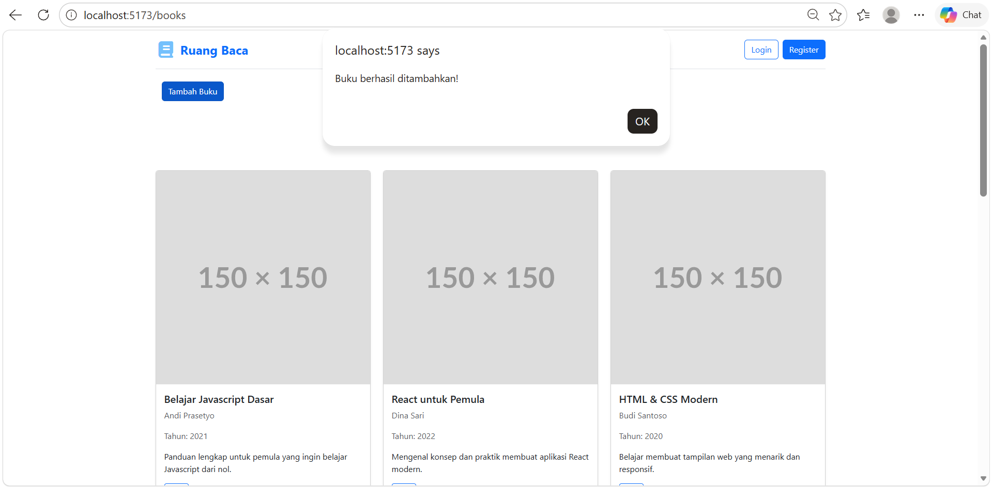

Buku yang di tambahkan dibuat berbeda sendiri cover nya, saya sengaja agar membedakan. Buku yang di tampilkan lainnya menggunakan web https://placehold.co/150 seperti contoh video. Sisa nya tidak ada yang saya ubah

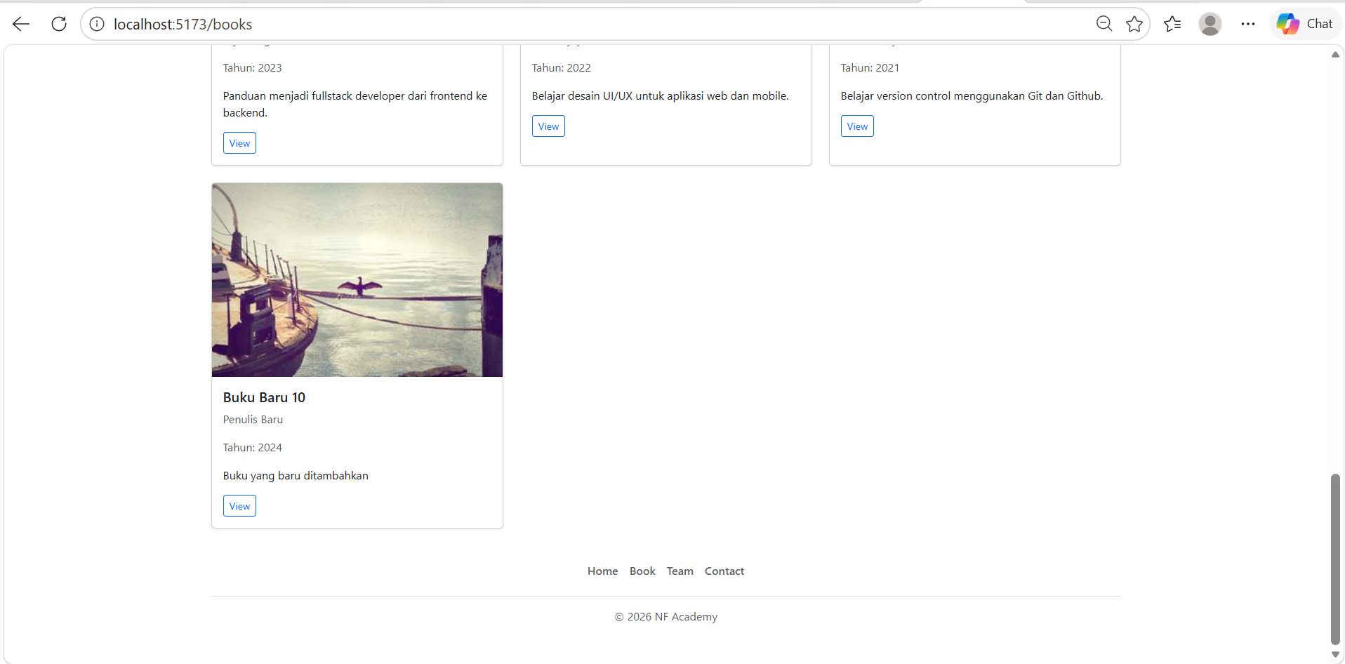

- Code yang di ganti itu ada beberapa yaitu di halaman:
- App.jsx
- import { BrowserRouter, Routes, Route } from "react-router-dom";
- import './App.css'

- import Books from './components/Pages/auth/books'
- import Home from './components/Pages'
- import Login from './components/Pages/auth/login'
- import Register from './components/Pages/auth/register'
- import Team from "./components/shared/Team";
- import Contact from "./components/shared/Contact";

- function App() {
- return (
- <BrowserRouter>
- <div className="container">
- <Routes>
- <Route path="/" element={<Home />} />
- <Route path="/books" element={<Books />} />
- <Route path="/login" element={<Login />} />
- <Route path="/register" element={<Register />} />
- <Route path="/team" element={<Team />} />
- <Route path="/contact" element={<Contact />} />
- </Routes>
- </div>
- </BrowserRouter>
- )
- }

- export default App;

- ProductList file nya index.jsx

- export default function ProductList({ data = [] }) {
- return (
- <>
- <section id="books" className="text-center mb-5">
- <h2>Best Seller Books</h2>
- <p className="text-muted">
- Koleksi buku terbaik pilihan pembaca
- </p>
- </section>

- <div className="row g-4">
- {data.map((book, i) => (
- <div className="col-md-4" key={book.id || i}>
- <div className="card shadow-sm h-100">
- <img
- src={book.image || `https://picsum.photos/300/200?random=${i}`}
- className="card-img-top"
- alt={book.title}
- />
- <div className="card-body">
- <h5>{book.title}</h5>
- <p className="text-muted">{book.author}</p>
- <p className="text-muted">Tahun: {book.year}</p>
- <p>{book.description}</p>

- <button className="btn btn-sm btn-outline-primary">
- View
- </button>
- </div>
- </div>
- </div>
- ))}
- </div>
- </>
- );
- }

- Books file nya index.jsx
- import { useState } from "react";
- import booksData from "../../../../Utils/books";
- import Footer from "../../../shared/Footer";
- import Header from "../../../shared/Header";
- import ProductList from "../../../shared/ProductList";

- export default function Books() {
- const [books, setBooks] = useState(booksData || []);

- const tambahBuku = () => {
- const bukuBaru = {
- id: books.length + 1,
- title: `Buku Baru ${books.length + 1}`,
- author: "Penulis Baru",
- year: 2024,
- description: "Buku yang baru ditambahkan",
- image: `https://picsum.photos/300/200?random=${books.length + 1}`
- };

- setBooks((prevBooks) => [...prevBooks, bukuBaru]);

- alert("Buku berhasil ditambahkan!");
- };

- return (
- <>
- <Header />

- <div className="container mt-4">
- <button onClick={tambahBuku} className="btn btn-primary mb-3">
- Tambah Buku
- </button>
- </div>

- <ProductList data={books} />

- <Footer />
- </>
- );
- }

- Folder Utils yang ada di arahan tugas dengan file books.js

- const books = [
- {
- id: 1,
- title: "Belajar Javascript Dasar",
- author: "Andi Prasetyo",
- year: 2021,
- description: "Panduan lengkap untuk pemula yang ingin belajar Javascript dari nol.",
- image: "https://placehold.co/150"
- },
- {
- id: 2,
- title: "React untuk Pemula",
- author: "Dina Sari",
- year: 2022,
- description: "Mengenal konsep dan praktik membuat aplikasi React modern.",
- image: "https://placehold.co/150"
- },
- {
- id: 3,
- title: "HTML & CSS Modern",
- author: "Budi Santoso",
- year: 2020,
- description: "Belajar membuat tampilan web yang menarik dan responsif.",
- image: "https://placehold.co/150"
- },
- {
- id: 4,
- title: "Node.js Dasar",
- author: "Rina Kurnia",
- year: 2021,
- description: "Panduan backend menggunakan Node.js untuk pemula.",
- image: "https://placehold.co/150"
- },
- {
- id: 5,
- title: "Database MySQL",
- author: "Agus Salim",
- year: 2019,
- description: "Belajar database MySQL dari dasar hingga lanjutan.",
- image: "https://placehold.co/150"
- },
- {
- id: 6,
- title: "Algoritma & Struktur Data",
- author: "Siti Rahma",
- year: 2020,
- description: "Konsep penting algoritma dan struktur data untuk programmer.",
- image: "https://placehold.co/150"
- },
- {
- id: 7,
- title: "Fullstack Developer",
- author: "Fajar Nugroho",
- year: 2023,
- description: "Panduan menjadi fullstack developer dari frontend ke backend.",
- image: "https://placehold.co/150"
- },
- {
- id: 8,
- title: "UI/UX Design",
- author: "Lina Wijaya",
- year: 2022,
- description: "Belajar desain UI/UX untuk aplikasi web dan mobile.",
- image: "https://placehold.co/150"
- },
- {
- id: 9,
- title: "Git & Github",
- author: "Eko Prasetyo",
- year: 2021,
- description: "Belajar version control menggunakan Git dan Github.",
- image: "https://placehold.co/150"
- }
- ];

- export default books;

